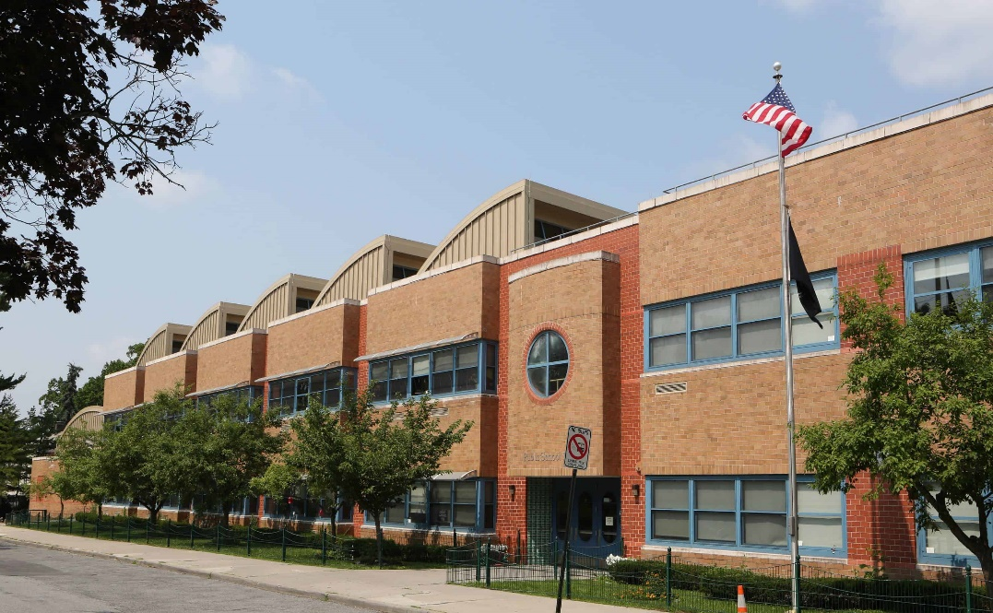

MINIMUM CAPACITY :-
The Minumum intake capacity
of students is between 300-620
children

LIBRARY :-
The Libarary is Available.

CANTEEN:-
The Canteen Facility is Available.

BOARDING :-
No availablility of boarding.

SPORTS :-
There are different categories
sports available.
Girls Volleyball
Boys Volleyball
Football

PAIDEIA SCHOOL 15
YONKERS - SCHOOL

School Detail :-
Paideia School 15 is a magnet school located in Yonkers, NY, which is in a large suburb setting. The student population of Paideia School 15 is 559 and the school serves PK-8. At Paideia School 15, 48% of students scored at or above the proficient level for math, and 34% scored at or above that level for reading.
. At Paideia School 15, 48% of students scored at or above the proficient level for math, and 34% scored at or above that level for reading.

